**Finn Lincoln – Data Project – MND442 – Prof Upton**

**Nuclear Project**

**Final Piece**

On the morning of Aug. 6, 1945, the United States rewrote human history as the Enola Gay flew over Hiroshima, Japan, dropping the first of two atomic bombs ever used in war.

Today, the repercussions of nuclear development impact the entire globe. Recently, the United Nations has warned the world of the possibility of a “humanitarian catastrophe of epic proportions” (Al Jazeera).

According to recent data, the amount of nuclear weapons has decreased by 85 percent from its peak of nearly 65,000 in the mid-eighties. However, many experts believe that increased diversity in states with nuclear capabilities could result in more trouble than ever before.

For example, tensions between the U.S. and North Korea are spiking as the U.S. has looked to provide nuclear weapons to South Korea in an attempt to keep North Korea at bay (Al Jazeera). North Korea has raised tensions as a result, claiming that the U.S. is preparing for a pre-emptive strike (Al Jazeera).

On the opposite side of the globe, tensions between Russia and the West have risen with the ongoing invasion of Ukraine. This development, along with the war itself, has heightened fears on a global scale of what could happen next (U.N. News).

In the Middle East, conflicts between Israel, Palestine, Iran, and other nations have also put people and organizations across the globe on high alert as some of these nations seek to proliferate their nuclear arsenals further.

Louis Kriesberg, Syracuse University professor and seasoned author on the topic of international conflict, believes there is not much reason to worry. He says, “People really don’t want to use these things. It’s a badge of prestige.”

Kriesberg thinks many developed and stable nations with nuclear capabilities will likely never look to use their nuclear arms. However, unstable nations could shift this narrative if they gain access to these powerful weapons.

Data provided by the Nuclear Threat Initiative gives more insight into the state of nuclear security in every country and shows how Kriesberg might be wrong. A matrix including all the data points can be used to compare the security of the 11 nations currently developing nuclear weapons.

Each nation received grades based on various security metrics such as compliance with global nuclear codes, risk environment in the country, and others. When using these metrics to grade the 11 nations, a wide range is uncovered on the scale.

The United Kingdom, United States, France, and India all score over 20 on the scale, indicating a strong balance of security, compliance with global codes, and commitment to de-proliferation.

In the middling category, China, Russia, Israel, and Pakistan all score between 19 and 15. Despite some uncertainties in these nations, they are all reasonably secure. They are generally not a threat to global nuclear security.

In the final bracket, perhaps unsurprisingly, are the most unstable countries with significant risk. Syria is rated a nine-point-five. Iran received a six-point-five. North Korea, with the lowest score by far, stands at a four-point-three. Based on the matrix, these three nations, all currently looking to bolster their nuclear arsenals, are the most significant threats to world peace from a nuclear standpoint.

According to Diane Swords, co-chair of the Nuclear Free World Committee, tensions are only so high because nuclear powers such as the U.S. are threatening these smaller nations. According to Swords, the best option for solving this issue is to “lower the tensions in the world so that U.S. sanctions are not causing these countries to feel that if they don’t have weapons to threaten us with, we will walk right over them.”

According to Professor Renée de Nevers of Syracuse Universities international affairs program, tensions have built because nuclear powers use their capabilities to strong-arm others. De Nevers explains that many states “rejected the non-proliferation treaty as creating a two-tiered system, which, of course, it does.” This fact indicates that although many nations want de-proliferation, nuclear possessors use their power to maintain the status quo where they have control.

Lawrence Wittner, author and professor at SUNY Albany, agrees that this two-tiered system has fostered resentment around the globe. Wittner describes how “that resentment showed up in the decision of the Indian Government or Pakistani Government during the late 20th century, to build their own nuclear weapons.”

However, Wittner believes the most significant underlying problem is global international tensions “leading to war. This precedent historically means that there’s any temptation for nations to build the most powerful weapons they could.” Other data can give us a more profound indication of just how much of domination nuclear powers have.

Numbers collected by Our World in Data provide specific statistics concerning support of nuclear proliferation by nations over time and counts on nations’ atomic stockpiles over time. Some interesting trends emerge through this data.

When looking at nuclear weapons stockpiles by nation over the years, the most noticeable trend is that although the U.S. and Russia possessed over 95% of the nuclear weapons in the world through the 1990s, the balance of power has significantly shifted.

In 2023, nations such as China (four percent), France (three percent), and the UK (two-point-five percent) have more significant stockpiles relative to the rest of the world than ever before. Even smaller nations with more recent histories in proliferation, such as Pakistan (two percent), North Korea (point-three-one percent), and India (two percent), have much more significant shares of the world’s nuclear population than they once did.

These numbers indicate that the balance of nuclear power is spreading throughout the world rather than just the U.S. and Russia. Because one nuclear weapon can cause so much damage, any nation with even one warhead could prove to be a threat.

De Nevers sees this development as a huge positive, mainly because it stems from the U.S. and Russia downsizing from their stockpiles of the Cold War, which consisted of tens of thousands of warheads. However, once these countries, such as China, expand beyond 50 or so warheads, de Nevers finds some concerns.

“It had about 20, and that was enough to stop anybody from attacking China,” de Nevers says. “So then the question is, why do you need more? If it’s really a deterrent, why do you need more?” This point shows how most nations making nuclear developments do not stop at the threshold of ‘deterrence.’

Another metric provided by OWID shows how many countries were pursuing nuclear arms in any given year, giving more context to de Nevers’ claims around increased balance. This metric gives countries considering nuclear weapons a score of one, nations pursuing them a two, and nations that possess these weapons get a three. Nations with no nuclear goals get a zero.

According to de Nevers, there are typically only two reasons that nations seek nuclear proliferation. The first is “states that feel threatened by their neighbors. You can see it in relations between Pakistan and India or even Iran with the U.S. One of the messages following the invasion of Iraq was people who said quite bluntly, ‘if you don’t want to be invaded by the U.S., you better have nuclear weapons.’”

De Nevers says the second reason, which aligns with Kreisberg's thoughts, is that “it gives a state more prestige. It’s seen as an element of modernization and superior science and technology.”

With this metric on proliferation goals, we can see that 1987 was the peak of nuclear proliferation, with 19 nations seeking nuclear arms, giving it a score of 42. Although the score has stagnated at 30 since 2008, an interesting detail is that between the peak of 1987 and where we are today, there has been a minimal increase in nations with nuclear weapons. The leading cause for this decrease is that many nations in the ‘consideration’ and ‘pursuit’ categories have dropped out of the race.

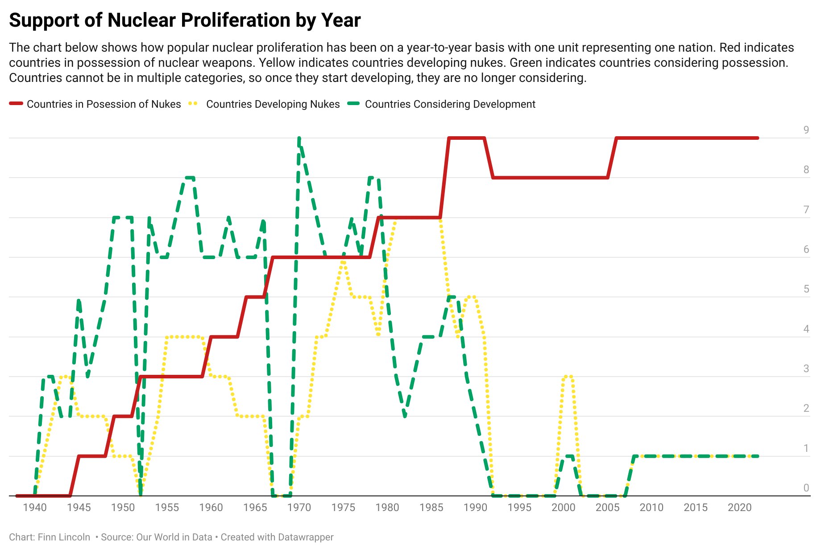

According to Swords, this shift has been forced by nuclear nations looking to consolidate power. She describes, “The non-proliferation treaty signed in 1972 put into place a system where new countries weren’t supposed to develop nuclear weapons. The countries who do have them were supposed to disarm, but there was no timetable, and it also enshrined that countries were entitled to nuclear power.”

Despite her somewhat pessimistic outlook, Swords explains, “The common people have made changes throughout history, so I try to remember that.”

In Wittner’s opinion, the best way to mitigate the threat of nuclear weapons is to strengthen the United Nations to help enforce de-nuclearization. Wittner believes that if the U.N. were “strong enough, would be able to foster disarmament generally, among major powers, and push nations back from the brink of war. They could resolve conflicts as in the Middle East, for example, right now.”

“It’s an international body that reflects the will of all the nations of the world,” Wittner added. “Ever since it was created, it has been responsible for ending war and dealing with international conflict.”

Although there seem to be so many in a stance against the proliferation of nuclear weapons, global tensions have resulted in a climate where global nuclear security is more unstable than ever.

The resolution of these problems seems unlikely as nuclear regulation has an increasing discontinuity. However, de-nuclearization appears to be in the hands of powerful nations who are unwilling to give up their bargaining chips. Overall, questions remain on what lies next in the story of nuclear arms.

**Works Cited:**

Al Jazeera. “UN Warns of ‘humanitarian Catastrophe’ in Growing Nuclear Arms Race.” *Al Jazeera*, Al Jazeera Media Network, 27 Sept. 2023, www.aljazeera.com/news/2023/9/27/un-warns-of-humanitarian-catastrophe-in-growing-nuclear-arms-race.

UN News. “World News in Brief: Ukraine Nuclear Plant Update, Sudan Health Crisis, Reproductive Rights | UN News.” *United Nations*, United Nations, 25 Sept. 2023, news.un.org/en/story/2023/09/1141402.

**Data and Analysis:**

<https://docs.google.com/spreadsheets/d/1K43oGXb4MnongbbOXYCiEYthaXBnkGOM/edit?usp=sharing&ouid=106610731587715077711&rtpof=true&sd=true>

**Sources:**

|  |  |  |  |
| --- | --- | --- | --- |
| **Source** | **Title** | **Date** | **Contact Info** |
| Louis Kriesberg (he/him) | SU Professor Emeritus and Acclaimed Author | October 9th 2pm, 35 minute discussion | 315-416-7379 - lkriesbe@syr.edu |
| Diane Swords (she/her) | Syracuse Peace Council and Nuclear Free World Committee Member | October 13th 1:30pm, 45 minute discussion | 315-391-4484 - dswords@gmail.com |
| Renée de Nevers (she/her) | SU Associate Professor and Acclaimed Author | October 23rd 12pm, 30 minute discussion | 315-443-7093 - denevers@syr.edu |
| Lawrence Wittner (he/him) | Professor Emeritus at SUNY Albany, Acclaimed Author, and Member of Multiple Activism Organizations Such as Peace Action | November 7th 4:30pm, 25 minute discussion | 518-462-6005 - larrywittner@gmail.com |

**Powerpoint:**

<https://docs.google.com/presentation/d/1bHSYAMFNNT6-erwJohWzYrNXyi05VveFGIw7ULjnlt4/edit?usp=sharing>